Lab 4Solutions

**Name**: Kaushik Raj V Nadar

**Roll No.:** 208160499

**Date:** 20/08/2024

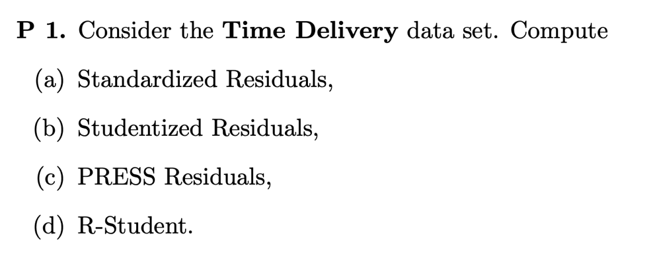

**Code:**

library(readxl)

# Load the Data

data <- read_excel("TimeDeliveryData.xlsx")

X1 <- data$X1

X2 <- data$X2

Y <- data$Y

# Combine X1 and X2 into a matrix of predictors

X <- cbind(1, X1, X2) # Add a column of 1s for the intercept term

# Fit the linear model using ordinary least squares

# Compute the coefficients (beta) using the normal equation:

# beta = (X'X)^-1 * X'Y

XtX <- t(X) %*% X

XtX_inv <- solve(XtX)

XtY <- t(X) %*% Y

beta <- XtX_inv %*% XtY

# Calculate the fitted values

fitted_values <- X %*% beta

# Calculate residuals

residuals <- Y - fitted_values

# Print results

cat("Coefficients: ", beta,'\n')

cat("Fitted values: ", fitted_values,'\n')

cat("Residuals: ", residuals,'\n')

# Calculate the standard deviation of the residuals

sigma_squared <- sum(residuals^2) / (length(Y) - ncol(X))

std_dev_residuals <- sqrt(sigma_squared)

# Calculate standardized residuals

standardized_residuals <- residuals / std_dev_residuals

cat("Standardized Residuals: ", standardized_residuals)

# Calculate Studentized Residuals

H <- X %*% XtX_inv %*% t(X)

studentized_residuals <- standardized_residuals/sqrt(1-diag(H))

cat("Studentized Residuals: ", studentized_residuals)

# Calculate PRESS Residuals

press_residuals <- residuals/(1-diag(H))

cat("PRESS Residuals: ", press_residuals)

# Calculate R-Student Residuals

e_sq_term <- residuals^2 / (1 - diag(H))

S_squared <- (sum(residuals^2) - e_sq_term)/(length(Y) - ncol(X) -1)

R_student_residuals <- residuals/sqrt(S_squared*(1-diag(H)))

cat("R-Student: ", R_student_residuals)

**Output:**

> cat("Coefficients: ", beta,'\n')

Coefficients: 2.341231 1.615907 0.01438483

> cat("Fitted values: ", fitted_values,'\n')

Fitted values: 21.70808 10.35361 12.07979 9.955646 14.1944 18.39957 7.155376 16.6734 71.82029 19.12359 38.09251 21.59304 12.47299 18.68246 23.3288 29.66293 14.91364 15.55138 7.706807 40.88797 20.51418 56.00653 23.35757 24.40285 10.96258

> cat("Residuals: ", residuals,'\n')

Residuals: -5.028084 1.146385 -0.0497937 4.924354 -0.4443983 -0.2895743 0.8446235 1.156605 7.419706 2.376413 2.237493 -0.5930409 1.027009 1.067536 0.6712018 -0.6629284 0.4363603 3.448621 1.793193 -5.78797 -2.614179 -3.686528 -4.607568 -4.572854 -0.2125839

> cat("Standardized Residuals: ", standardized_residuals)

Standardized Residuals: -1.542606 0.3517088 -0.01527661 1.510782 -0.1363405 -0.08884082 0.2591288 0.3548441 2.276351 0.7290788 0.6864584 -0.1819438 0.3150844 0.3275179 0.2059234 -0.2033851 0.1338745 1.05803 0.5501482 -1.775738 -0.8020249 -1.131019 -1.413593 -1.402942 -0.06522033

> cat("Studentized Residuals: ", studentized_residuals)

Studentized Residuals: -1.62768 0.3648427 -0.01609165 1.57972 -0.1417609 -0.09080847 0.270425 0.3667212 3.213763 0.8132543 0.7180797 -0.1932573 0.3251794 0.3411355 0.2102914 -0.2227002 0.1380393 1.112952 0.5787663 -1.873546 -0.8778426 -1.449995 -1.44369 -1.496059 -0.06750861

> cat("PRESS Residuals: ", press_residuals)

PRESS Residuals: -5.597967 1.233603 -0.05524867 5.384013 -0.4804361 -0.3025434 0.9198675 1.235327 14.7889 2.956826 2.448378 -0.6690864 1.093872 1.158154 0.6999785 -0.7948214 0.4639328 3.815946 1.984606 -6.44314 -3.131792 -6.059135 -4.805858 -5.200019 -0.2277628

> cat("R-Student: ", R_student_residuals)

R-Student: -1.695629 0.3575376 -0.01572177 1.639165 -0.1385649 -0.08873728 0.2646477 0.3593898 4.31078 0.8067758 0.7099391 -0.1889745 0.3184692 0.3341772 0.2056632 -0.2178257 0.134924 1.119331 0.5698142 -1.996677 -0.873087 -1.489625 -1.482467 -1.542215 -0.06596332

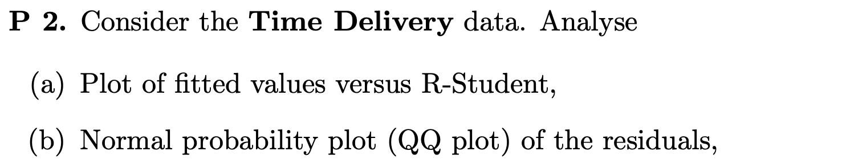

**Code:**

# Plot Fitted Values vs. R-Student

plot(fitted_values, R_student_residuals,

xlab = "Fitted Values",

ylab = "R-Student",

main = "Fitted Values vs. R-Student")

abline(h = 0, col = "red")

# QQ Plot

qqnorm(residuals)

qqline(residuals, col = "red")

**Output:**

